AI BLOGNEST – PROJECT DEVELOPMENT LIFECYCLE DOCUMENT

1. BRAINSTORMING AND IDEATION
The idea behind AI BlogNest began with a simple observation: individual content creators and small publishing teams often struggle to manage multiple blogs, organize drafts, and consistently produce high-quality articles. The team brainstormed ways to combine a traditional blogging backend with modern Generative AI capabilities, so that writers could get help with content generation and summarization while still keeping full control over publishing workflows.
During this phase, the team explored several directions, including a plain CMS without AI features, a pure AI writing tool without any content management, and a hybrid approach. The hybrid approach was chosen because it offered the most value: a secure, role-based backend for managing blogs, combined with Google Gemini AI for content generation, summarization, and other smart assistance features such as WeatherWise insights and FitTrack recommendations.
The final concept, named BlogNest, was defined as an AI-powered Content Management System that lets Admins, Editors, Authors, and Readers collaborate on a single platform while using AI to speed up the writing and editing process.

2. REQUIREMENT ANALYSIS
Once the concept was finalized, the team analyzed what the system needed to do and identified the key stakeholders and their needs. The main problems considered were the difficulty of managing many drafts, categories, and tags; limited visibility into post performance; slow approval and moderation processes; and the lack of clear permission levels between editors, authors, and administrators.

FUNCTIONAL REQUIREMENTS
- User registration, login, and authentication using JWT.
- Role-based access control for Admin, Editor, Author, and Reader.
- CRUD operations for blog posts, categories, tags, and comments.
- AI-powered blog generation and content summarization using Google Gemini AI.
- Search, filtering, and media metadata handling.

NON-FUNCTIONAL REQUIREMENTS
- Security measures such as password hashing, input sanitization, and rate limiting.
- Scalability to support multiple concurrent users and blogs.
- Centralized error handling and structured logging for reliability.

SOFTWARE REQUIREMENTS
- Operating System: Windows 10/11, macOS, or Linux (cross-platform support).
- Node.js: Version 16 or above, used to run the server logic and routing.
- npm: Version 8 or above, used to manage project dependencies.
- Express.js: A lightweight framework used to build the RESTful endpoints.
- MongoDB: The NoSQL database used to store users, posts, categories, comments, and analytics.
- Postman: Used to test and verify API responses and role-based access.
- Code Editor: Visual Studio Code or a similar IDE.

HARDWARE REQUIREMENTS
- Processor: Intel Core i5 (8th generation or above), AMD Ryzen 5, or equivalent.
- RAM: Minimum 8 GB, 16 GB recommended for running MongoDB and the application together.
- Storage: At least 1 GB of free disk space.

3. PROJECT DESIGN PHASE
In the design phase, the team defined the overall architecture, the data model, and how different components of the system would interact. The backend was designed using a layered architecture, where each incoming request passes through authentication, validation, and business logic before reaching the database.

BACKEND ARCHITECTURE DIAGRAM
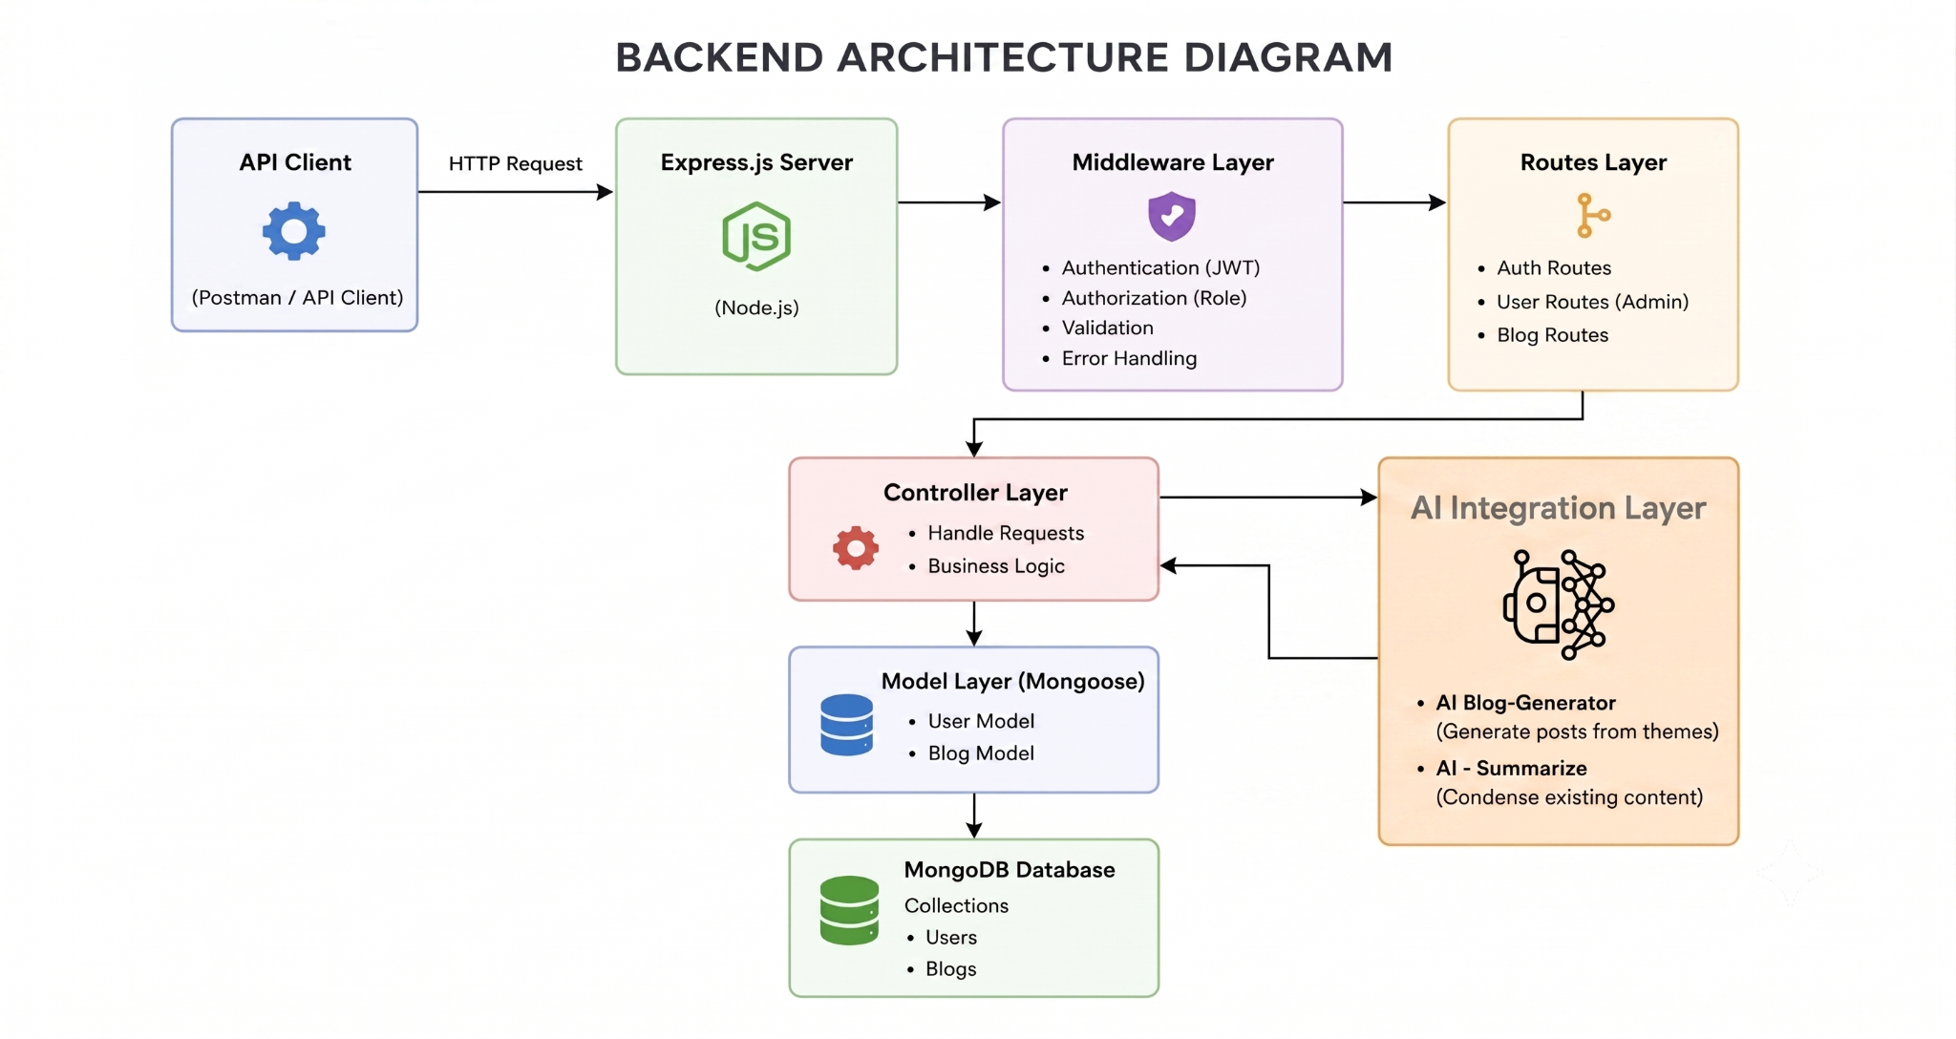
Layered backend architecture showing the flow from the API client through middleware, routes, controllers, models, and the AI integration layer.

ENTITY-RELATIONSHIP (ER) DIAGRAM
The data model was designed around four main entities — User, Blog Post, Category, and Comment — connected through relationships such as a user creating many posts, a post belonging to one category, and a post having many comments.

Entity-Relationship diagram of the User, Blog Post, Category, and Comment collections.

USER FLOW DIAGRAM
The user flow was mapped out to show how a request travels from authentication through role-based branching (User or Admin) to the AI services and database operations.
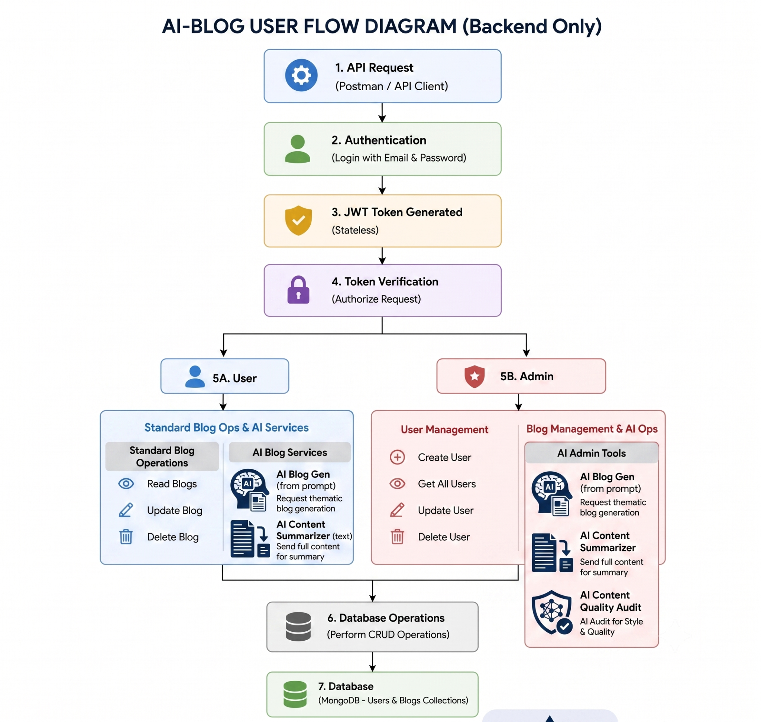
User flow diagram showing authentication, role branching, and AI service integration.

MVC ARCHITECTURE PATTERN
The system follows the Model-View-Controller pattern. The Model layer defines the Mongoose schemas, the Controller layer handles request processing and business logic, and since this is a headless backend, the View layer takes the form of an API routing layer instead of a visual interface.

MVC pattern adapted for a headless backend service.

4. PROJECT PLANNING PHASE
The planning phase broke the project down into manageable epics, each covering a distinct stage of development. This allowed the team to track progress and ensure that dependencies, such as setting up the database before writing controllers, were handled in the right order.
- Epic 1 – Project Architecture: Defining the overall backend architecture, the ER diagram, user flow, and the MVC pattern.
- Epic 2 – Project Setup and Configuration: Creating the project folder structure and initializing the Node.js server.
- Epic 3 – Backend Development: Building the Express server, application entry point, and route integration.
- Epic 4 – Database Configuration: Connecting to MongoDB and defining Mongoose schemas and models.
- Epic 5 – Project Execution and Testing: Running the server and verifying each endpoint using Postman or ThunderClient.
A rough timeline was also agreed upon, allocating time for setup, core backend development, AI integration, testing, and final documentation, with buffer time reserved for fixing issues found during testing.

5. PROJECT DEVELOPMENT PHASE
Development began with setting up the project folder and initializing the Node.js server using npm init -y. The project was organized into clear folders, including config, controllers, middleware, models, routes, and services, keeping the codebase modular and easy to maintain.
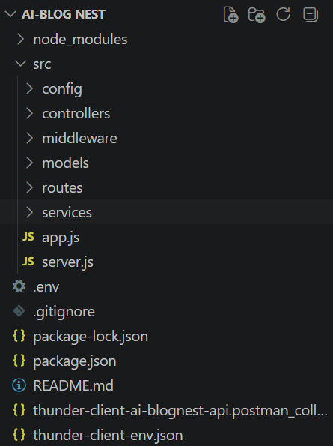
Project folder structure created in Visual Studio Code.

SERVER ENTRY POINT (SERVER.JS)
The server.js file loads environment variables, connects to the database, and starts the Express application on the configured port.
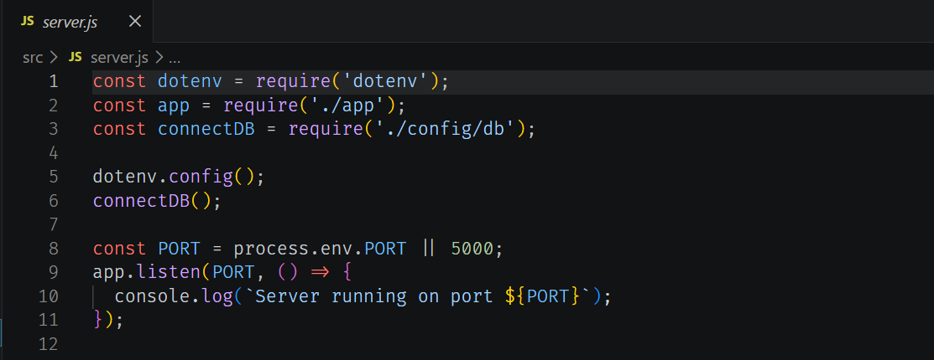

APPLICATION SETUP (APP.JS)
The app.js file configures middleware such as CORS, JSON parsing, and logging, and wires up the authentication, blog, and AI routes along with centralized error handling.
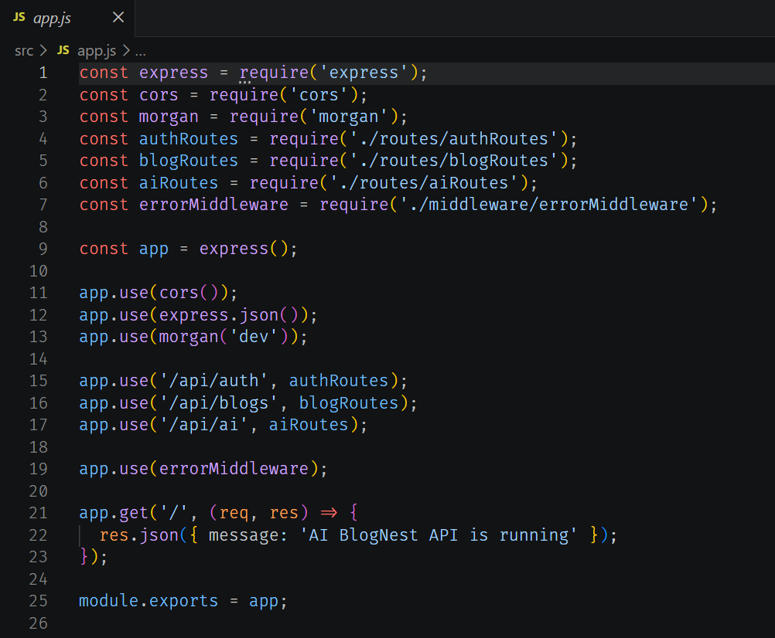

DATABASE CONNECTION
A dedicated connectDB function establishes the MongoDB connection using Mongoose, with error handling to stop the server if the connection string is missing or invalid.
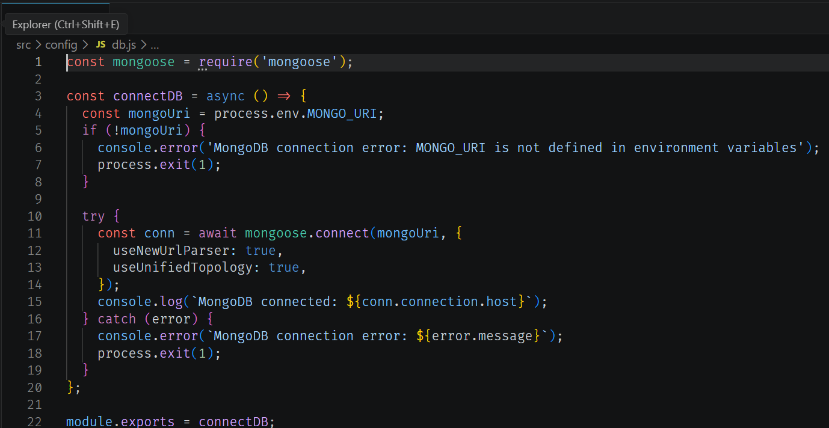

MONGOOSE SCHEMA DEFINITION
The User schema enforces validation rules such as required fields, a unique email address, and a minimum password length before any record is saved to the database.
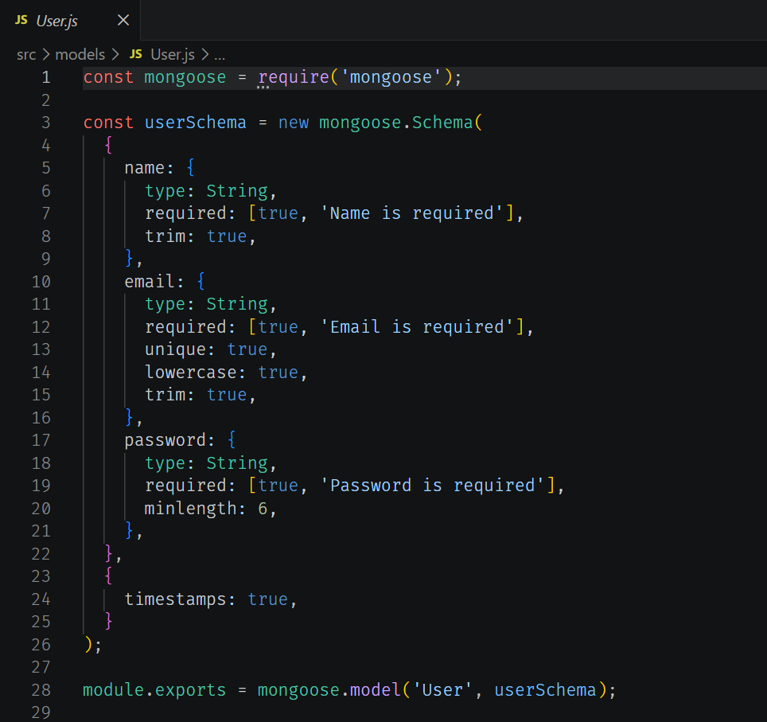

6. PROJECT TESTING
Once the core features were built, each endpoint was tested using Postman to confirm that authentication, blog management, and the AI features worked as expected under different roles and conditions.

USER REGISTRATION
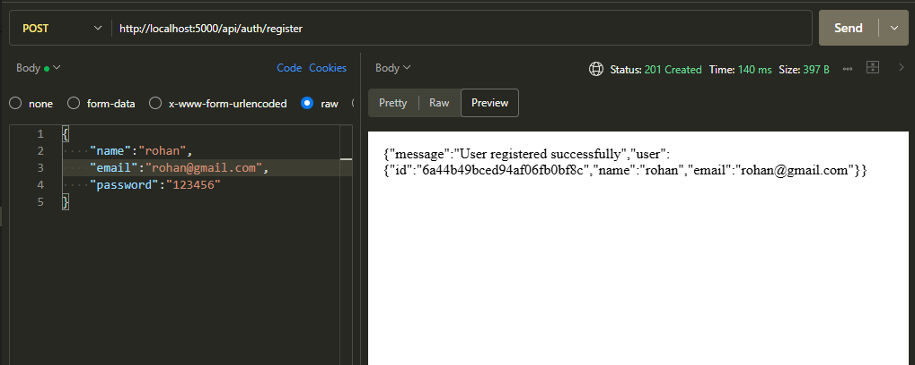

USER LOGIN
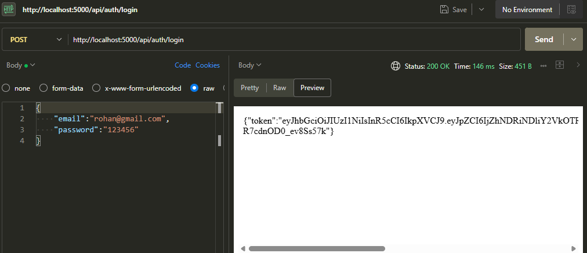

CREATE BLOG POST
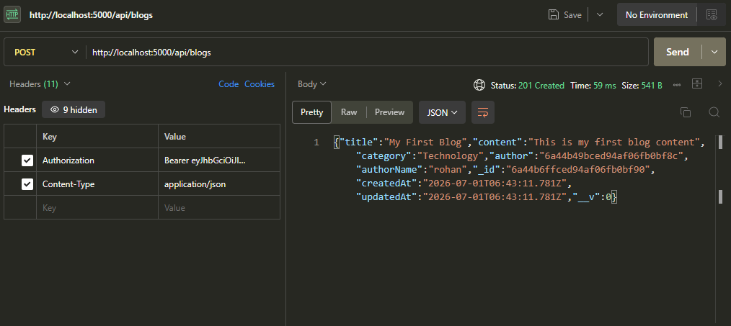

FETCH BLOG POSTS
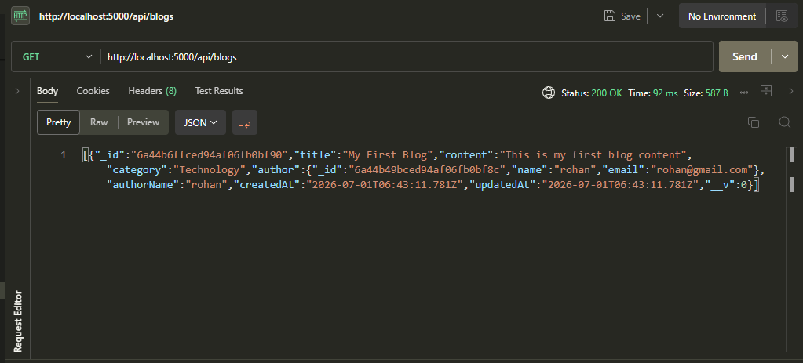

GENERATE AI BLOG
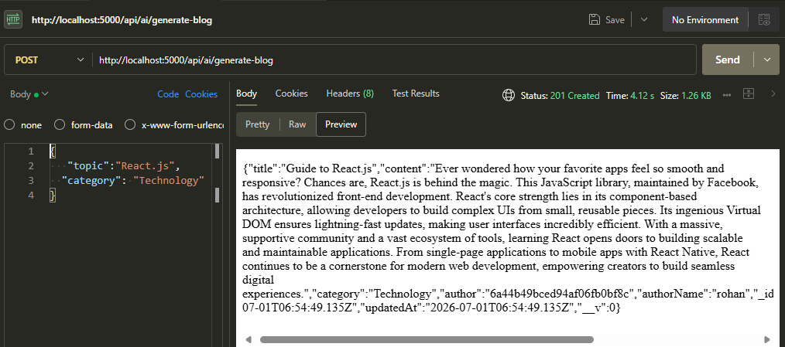

SUMMARIZE BLOG CONTENT
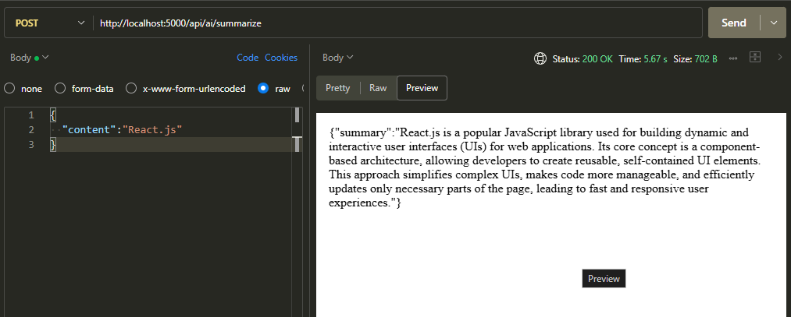
These tests confirmed that registration and login correctly issue JWT tokens, that blog posts can be created and retrieved with the right author and category data attached, and that the AI endpoints return well-formed, context-aware content and summaries.

7. PROJECT DOCUMENTATION
Throughout development, the project was documented to make it easy for other developers to understand the architecture, set up the environment, and use the API. Documentation covered the software and hardware requirements, the backend architecture and ER diagrams, the step-by-step setup instructions, and sample API requests and responses captured from Postman.
A Postman collection and environment file were also prepared and included with the project, allowing other developers to quickly import all the API routes and test them without manually configuring each request.

8. PROJECT DEMONSTRATION
The completed project was demonstrated by walking through the main workflows: registering and logging in as a user, creating and fetching blog posts, and using the AI features to generate a new blog post and summarize existing content. The demonstration highlighted how the role-based system, the database, and the AI integration work together smoothly.
Demo Video: Click here to watch the demo video

